Experiment No. | 4
Aim | Matrix Chain Multiplication using Dynamic Programming
Name | Sakshi D Lonare
UID No. | 2021300069
Class & Division | Comps SE A

Algorithm:-

- matOrder(array, n)
Begin
define table matmult of size n x n, initially fill with all 0s
for length := 2 to n, do
fir i:=1 to n-length, do
j := i + length – 1
matMul[i, j] := ∞
for k := i to j-1, do
q := matMul[i, k] + matMul[k+1, j] + array[i-1]*array[k]*array[j]
if q < matMul[i, j], then matMul[i, j] := q
done
done
done
return matMul[1, n-1]
End

Program:-

#include <stdio.h>
#include<limits.h>
#include<stdlib.h>

long int m[20][20];
int s[20][20];
int p[20],i,j,n;

void print_optimal(int i,int j)
{
if (i == j)
printf(" A%d ",i);
else
{
printf("( ");
print_optimal(i, s[i][j]);
print_optimal(s[i][j] + 1, j);
printf(" )");
}
}

void matmultiply(void)
{
long int q;
int k;
for(i=n;i>0;i--)
{
for(j=i;j<=n;j++)
{
if(i==j)
m[i][j]=0;
else
{
for(k=i;k<j;k++)
{
q=m[i][k]+m[k+1][j]+p[i-1]*p[k]*p[j];
if(q<m[i][j])
{
m[i][j]=q;
s[i][j]=k;
}
}
}
}
}
}

int MatrixChainOrder(int p[], int i, int j)
{
if(i == j)
return 0;
int k;
int min = INT_MAX;
int count;

for (k = i; k <j; k++)
{
count = MatrixChainOrder(p, i, k) +
MatrixChainOrder(p, k+1, j) +
p[i-1]*p[k]*p[j];

if (count < min)
min = count;
}

// Return minimum count
return min;
}

void main()
{
int k;
printf("Enter the no. of elements: ");
scanf("%d",&n);
for(i=1;i<=n;i++)
for(j=i+1;j<=n;j++)
{
m[i][i]=0;
m[i][j]=999999999;
s[i][j]=0;
}
printf("\nEnter the dimensions: \n");
for(k=0;k<=n;k++)
{
int upper=49, lower=15;
p[k]=(rand() % (upper - lower + 1)) + lower;
printf("P%d: ",p[k]);
}
matmultiply();
printf("\nCost Matrix M:\n");
for(i=1;i<=n;i++)
for(j=i;j<=n;j++)
printf("m[%d][%d]: %ld\n",i,j,m[i][j]);

i=1,j=n;
printf("\nMultiplication Sequence : ");
print_optimal(i,j);
printf("\nMinimum number of multiplications is : %d ",
MatrixChainOrder(p, 1, n));

}

Output:-
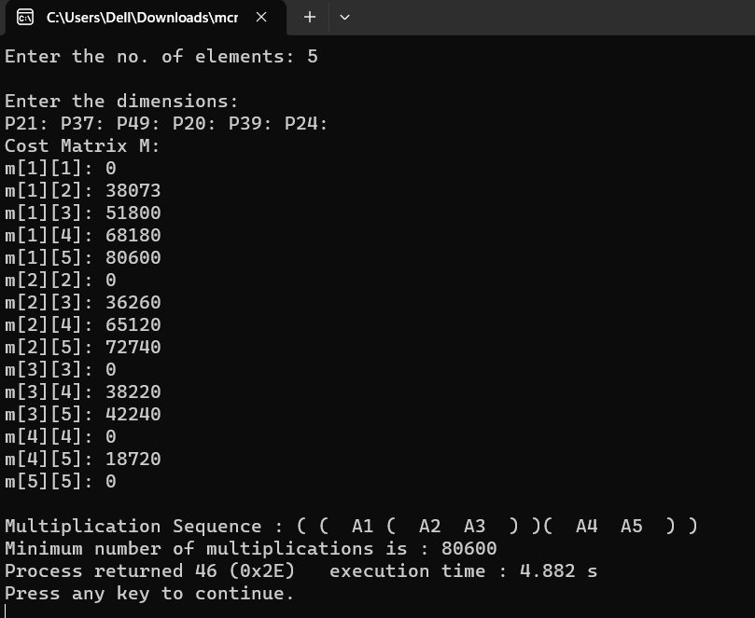

Conclusion: Learnt the implementation of matrix chain multiplication. Matrix chain multiplication is an important problem in computer science that involves finding the optimal way to multiply a sequence of matrices. Dynamic Programming is used for this.

